**List of textual reports**

On the desktop application, there will be some textual reports that the staff will be able to see as **today´s occupation of the cabins**, **the facturation by month/day** or some **statistic about the most used services**.

1. Today´s occupation of the cabins will be ordered by each hour of the day. There will be all the cabins and next to the hour, the customer as seen on the next example table:

| **22/03/2022** | **Cabin 1** | **Cabin 2** | **Cabin 3** | **Cabin 4** |
| --- | --- | --- | --- | --- |
| **8:00 – 9:00** | Ander Etxaniz  Id: AE1 |  |  |  |
| **9:00 – 10:00** |  |  | June Salas  Id: JS1 |
| **10:00 – 11:00** |  | Jon Gaztañares  Id: JG1 |  |  |
| **11:00 – 12:00** | Aitor Alberdi  Id: AA1 |  |  |  |
| CLOSED | CLOSED | CLOSED | CLOSED | CLOSED |
| **17:00 – 18:00** |  |  | Ane Elorza  Id: AE2 |  |
| **18:00 – 19:00** |  |  |  |
| **19:00 – 20:00** |  |  | Laura Larrañaga  Id: LL1 |

For this purpose, we will need to connect with our database and take the information from the exact day that the staff has entered by keyboard. This will be done connecting first with the database and then searching the specific date and then showing only that information on the format we want to show.

1. Facturation by month/day will have all the facturation done on the staff´s choice, like on a month or on a specific day. There will be the date (of the month or the day) on the top and then will have the facturation with details. On the very bottom, there will be all the total of the choice chosen (month or day) as seen on the next example table the facturation by day:

| **Date : 22 /03 /2022** |
| --- |
| Oil change ------------------------------------------------------------------------------------------70€  Oil change ------------------------------------------------------------------------------------------70€  General review ----------------------------------------------------------------------------------110€  Sheet metal and paint repair ---------------------------------------------------------------1121€  Spoiler modification ----------------------------------------------------------------------------700€  Oil change ------------------------------------------------------------------------------------------70€  General review ----------------------------------------------------------------------------------110€  Air conditioning change ------------------------------------------------------------------------65€ |
| TOTAL: -------------------- 2316€ |

For this purpose, we will need to connect with our database and take the information from there. To calculate the total of the facturation, we will need a counter that will be adding the prices of each element.

C)Statistics about the **most used services** option will display a statistic scheme with rectangles representing the amount of each services that customers book as seen on the next statistic for example:

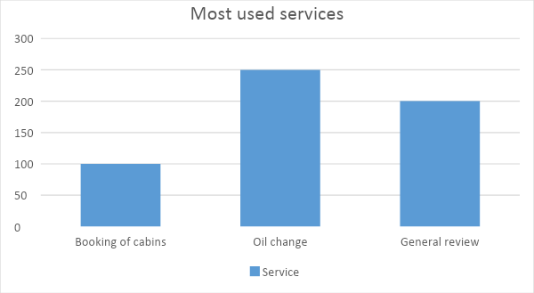

For this purpose, will be used the facturation information and calculate how many times our customers booked each service.

D) Statistics about the **customers amount** option will display a statistic scheme where will be represented between two dates the amount of customers by month/day. This all, will be created using the information from the database and counting how many customers were on each date. On the next graphic, you can see an example:

